Link for the Presentation and the report

<https://prezi.com/p/uojea_pwceai/>

Docker Image

<https://hub.docker.com/r/vinaygor/bigdata2017/>

Demo Screenshot

1. On Monday Holiday(March 20 2017)

Number of Visitors: 25

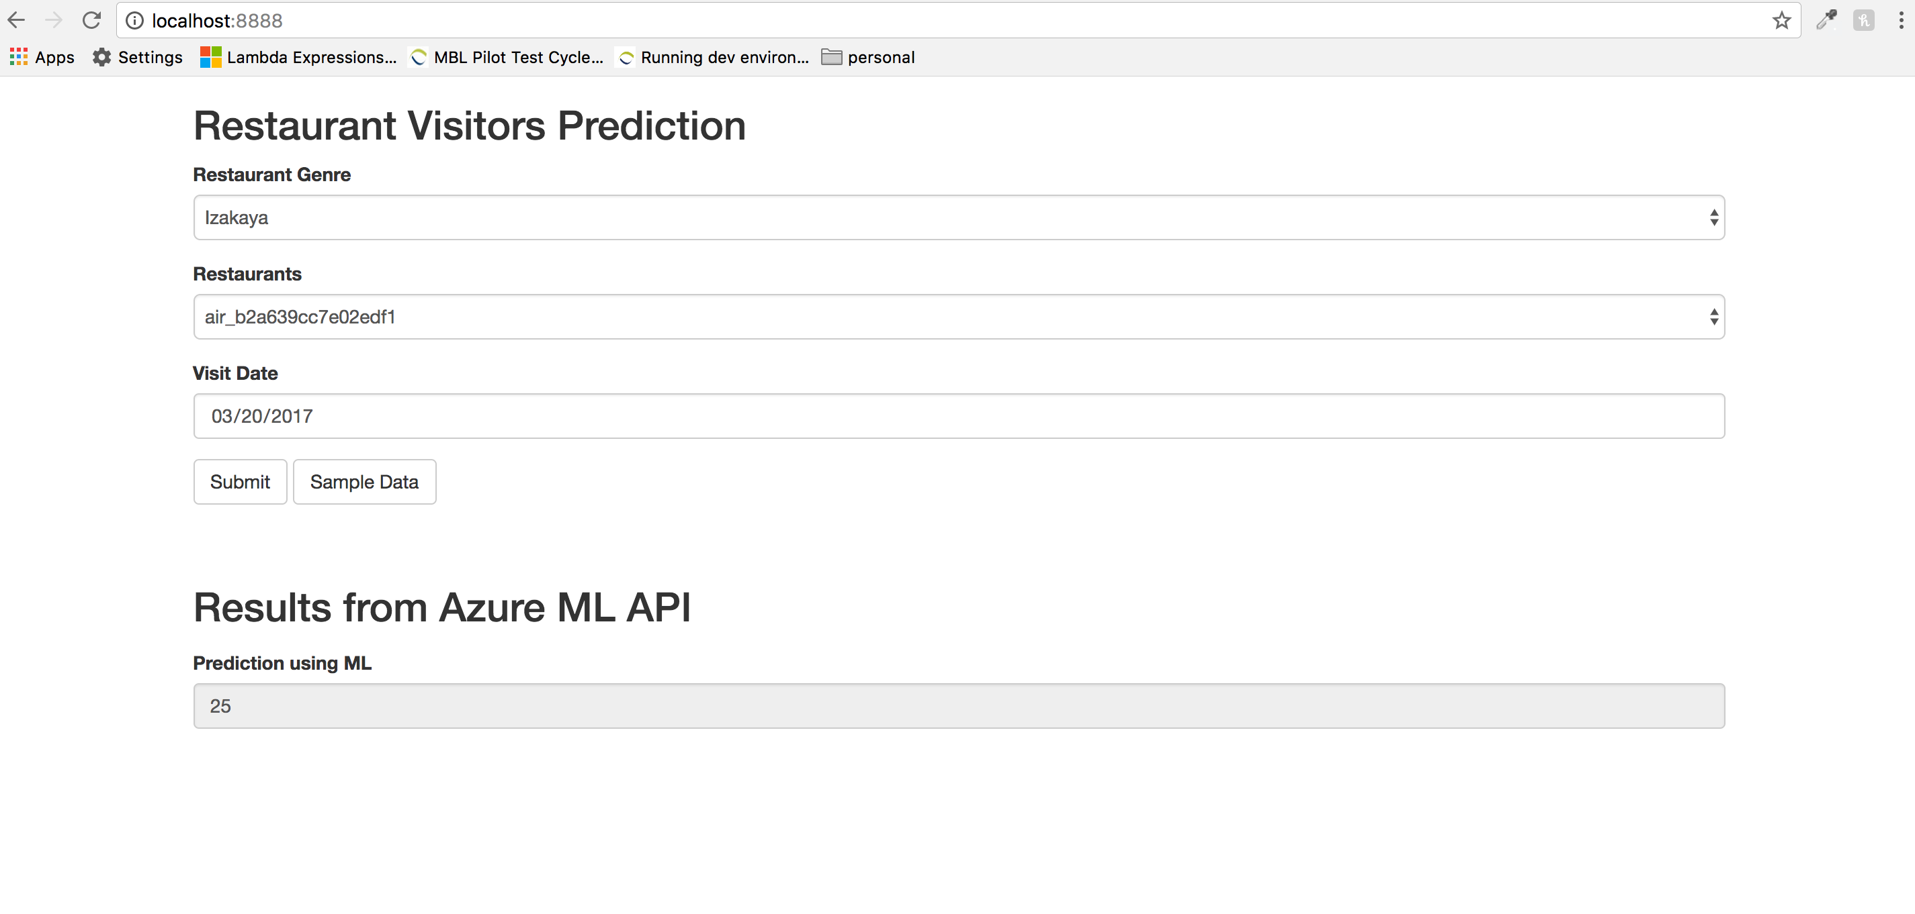

1. On Tuesday Non Holiday (March 21 2017)

Number of Visitors: 6

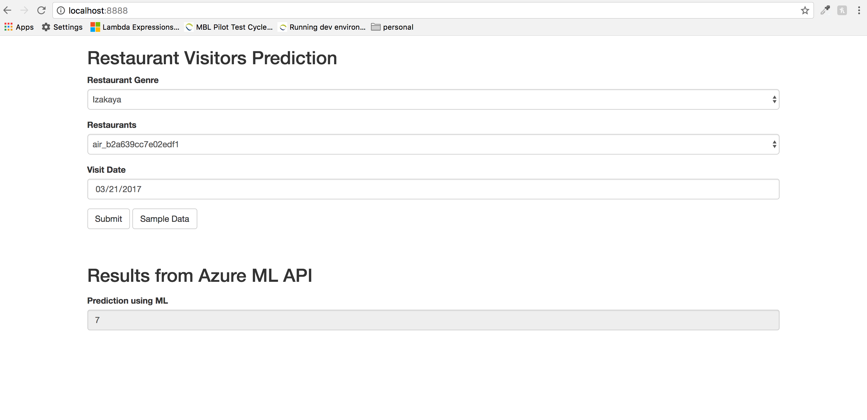

1. On Saturday Weekend(March 25 2017)

Number of Visitors : 54

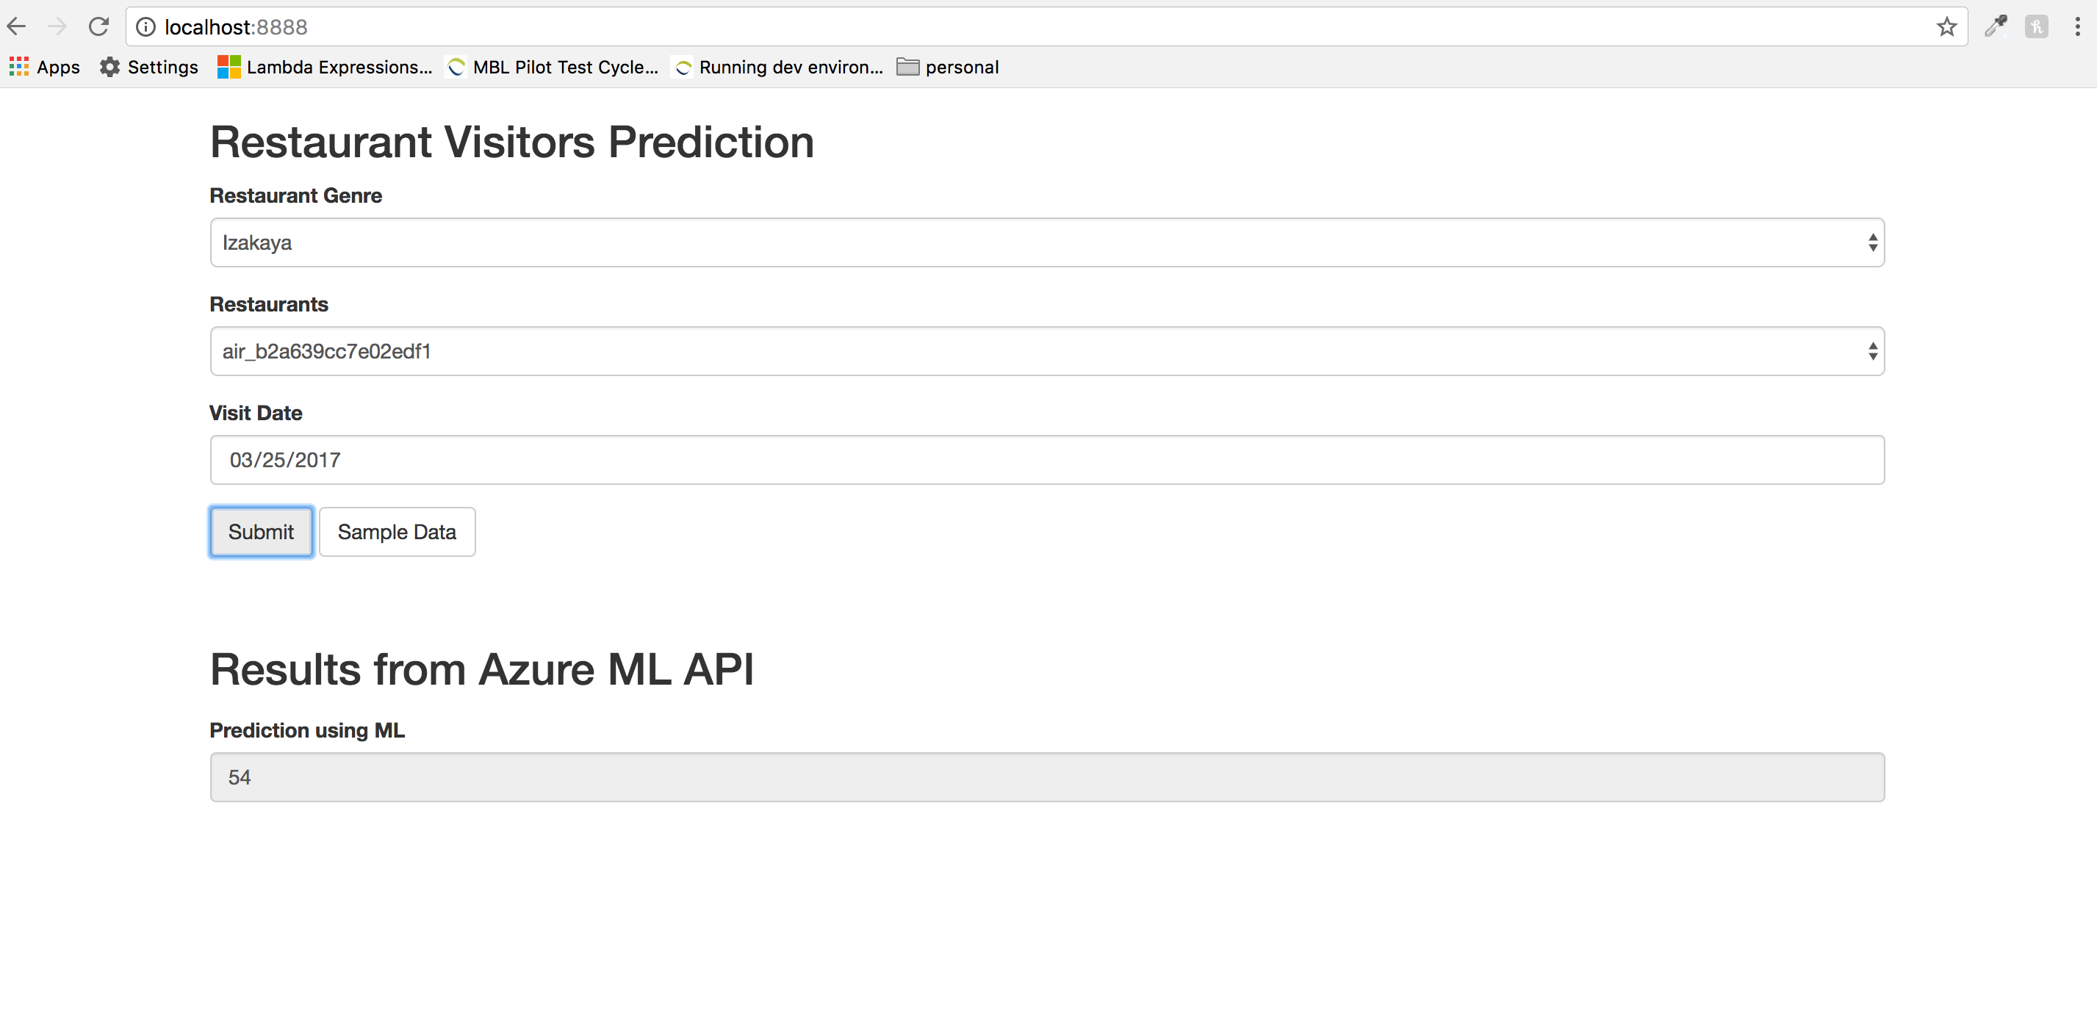

1. On Sunday Weekend (March 26 2017)

Number of Visitors : 33

